FACE MASK DETECTION AND PERSON IDENTIFICATION

##### **A PROJECT REPORT**

###### **Submitted by**

**N. KARTHIKEYAN 422117104022**

**S. ARUN PANDIYAN 422117104007**

**S. SANTHOSH 422117104045**

**G.P. VADALARASAN 422117104304**

***In partial fulfilment for the award of the degree***

***Of***

**BACHELOR OF ENGINEERING**

**IN**

**COMPUTER SCIENCE AND ENGINEERING**

­

ST. ANNE’S COLLEGE OF ENGINEERING AND TECHNOLOGY



**ANNA UNIVERSITY::CHENNAI 600 025**

**APRIL 2021**

**ANNA UNIVERSITY::CHENNAI 600 025**

**BONAFIDE CERTIFICATE**

Certified that this project report **“Face Mask Detection and Person Identification”** is the bonafide work of **N. KARTHIKEYAN (422117104022), S. ARUN PANDIYAN (422117104007), S. SANTHOSH (422117104045), G.P. VADALARASAN (422117104304)** who carried out the project work under my supervision.

**SIGNATURE SIGNATURE**

**Sr. A. PUNITHA JILT, M.Tech., Sr. A. PUNITHA JILT, M.Tech.,**

**HEAD OF THE DEPARTMENT SUPERVISOR**

Department of Computer Science Department of Computer Science

and Engineering, and Engineering,

St.Anne’s College of Engineering St.Anne’s College of Engineering

and Technology, and Technology,

Panruti-607 110. Panruti-607 110.

Submitted for the Project Viva-Voce examination held on …………………

**Internal Examiner External Examiner**

**ACKNOWLEDGMENT**

We would like to extend our sincere thanks to many individuals and organizations as it would not have been possible to complete this project without their kind support and help.

We would like to express our special graduate and thanks to our beloved Mother **Rev. Sr. Dr. Y. YESU THANGAM, SAT., Ph.D.,** Secretary, St. Anne’s College of Engineering and Technology and we are highly indebted to our respected Principal **Dr. R. AROKIADASS, ME., Ph.D.,** for giving us the opportunity to display our professional skill through this project.

We convey our exceptional gratitude to our guide **Sr. A. PUNITHA JILT, M.Tech.,** Head of the Department and Project Coordinator for giving valuable motivation to complete this project in time and support and providing necessary information to complete this project.

A special gratitude to **Mrs. D. PAULINE FREEDA** whose contribution for three years in stimulating suggestions and encouragement helped us to achieve our goal successfully.

We thank all our teaching staff members of Department of Computer Science & Engineering for their passionate support for helping us to identify our mistakes and also for appreciation they gave us in achieving our goals.

TABLE OF CONTENTS

CHAPTER NO TITLE **PAGE NO**

**ACKNOWL EDGEMENT**

**ABSTRACT v**

**LIST OF ABBREVIATIONS vi**

**LIST OF FIGURES vii**

**1 INTRODUCTION** 1

* 1. Objective 1
  2. Scope 1
  3. Organization of Project 2

**2** **LITRATURE SURVEY** 4

**3 SYSTEM ANALYSIS** 9 **3.1 Existing System** 9

3.1.1 Advantages 11 3.1.2 Disadvantages 11

**3.2 Proposed System** 11

3.2.1 Advantages 12

**4 SYSTEM REQUIREMENTS** 13

4.1 Hardware Requirements 13

4.2 Software Requirements 13

4.3 MATLAB Description 13

**5 SYSTEM DESIGN** 19

**5.1 System Architecture** 19

**5.2 System Study** 20

5.2.1 Feasibility Study 20

5.2.2 Economical Feasibility 20

5.2.3 Technical Feasibility 21

5.2.4 Social Feasibility 21

**5.3 Input Design** 21

**5.4 Output Design** 22

**5.5 UML Diagrams** 23

5.5.1 Use Case Diagram 26

5.5.2 Class Diagram 27

5.5.3 Sequence Diagram 28

5.5.4 Activity Diagram 29

**6 METHODOLOGY** 30

6.1 Support Vector Machine 30

6.2 MobileNet-V2 30

6.3 Single Shot Detector 30

6.4 Deep Neural Network 31

6.5 Convolutional Neural Network 31

**7 IMPLEMENTATION** 32

**7.1 Modules**  32

**7.2 Modules Description** 32

7.2.1 Feature Extraction 32

7.2.2 Face Detection 32

7.2.3 Person Identification 33

**8 SYSTEM TESTING** 34

**8.1 Verification and Validation** 34

**8.2 System Testing** 34

**8.3 Types of Tests** 35

8.3.1 Unit Testing 35

8.3.2 Functional Test 35

8.3.3 System Test 36

8.3.4 White Box Testing 36

8.3.5 Black Box Testing 36

8.3.6 Integration Testing 37

8.3.7 Acceptance Testing 38

**8.4 Test Strategy and Approach** 38

8.4.1 Test Objectives 38

8.4.2 Features to Be Tested 38

**9 CONCLUSION** 39

**10 FUTURE ENHANCEMENT** 40

**APPENDIX- I SCREENSHOTS** 41 **APPENDIX- II CODING** 46 **REFERENCES** 56

**ABSTRACT**

Face veil recognition had seen critical improvement in the areas of Image handling and Computer vision, since the ascent of the Covid-19 pandemic. Many face location models have been made utilizing a few calculations and methods. The proposed approach in this project utilizes profound learning, TensorFlow, Keras, and OpenCV to identify face veils. This model can be utilized for wellbeing purposes since it is very asset effective to convey. The SSDMNV2 approach utilizes Single Shot Multibox Detector as a face finder and person identification from the server and MobilenetV2 engineering as a structure for the classifier, which is extremely lightweight and can even be utilized in installed gadgets (like NVIDIA Jetson Nano, Raspberry pi) to perform continuous cover location. The strategy sent in this project gives us an exactness score of 0.9264 and a F1 score of 0.93. The dataset gave in this project, was gathered from different sources, can be utilized by different analysts for additional high level models like those of face acknowledgment, facial tourist spots, and facial part recognition measure and finally person identification.

**Keyword:** TensorFlow; Keras; OpenCV;

­­

**LIST OF ABBREVIATIONS**

CV Computer Vision

SSD Single Shot Multi-box Detector

MNV2 Mobile Net Version 2

CNN Convolutional Neural Network

SVM Support Vector Machine

DNN Deep Neural Network

RCT Randomized Controlled Trial

FCN Fully Convolutional Network­­

**LIST OF FIGURES**

CHAPTER TITLE **PAGE NO**

5.1 Architecture of Face Detection 19

5.2 Use Case Diagram 26

5.3 Class Diagram 27

5.3 Sequence Diagram 28

5.4 Activity Diagram 29

**CHAPTER 1**

**INTRODUCTION**

**1.1 Objective**

COVID-19 pandemic has had a lasting impact in many countries worldwide since December 2019. It originated in Wuhan, China. The World Health Organization (WHO) as on March 11, 2020, declared it as deadly diseases that gained its roots across the globe and severely affected 114 countries. Every medical professional, healthcare organizations, medical practitioners and researchers are in search for a proper vaccines and medicines to overcome this deadly disease, however no breakthrough has been reported till date. The virus spreads through air channel when an infected person sneezes or communicates with the other person, the water droplets from their nose or mouth disseminate through the air and affect other peoples in the vicinity. Face Mask detection has become a trending application due to the Covid-19 pandemic, which demands a person to wear face masks, keep social distancing, and use hand sanitizers to wash their hands. While other problems of social distancing and sanitization have been addressed until now, the issue of face mask detection has not yet been adequately addressed. Wearing a mask during this pandemic is a critical preventive measure and is most vital step in times when social distancing is hard o maintain. Wearing a mask is essential, particularly for those people who are at a greater risk of severe illness from COVID-19 diseases.

**1.2 Scope**

It is found that the spread of COVID-19 is mainly among people who are in immediate contact with one another (nearly about 6 feet); it can be spread by people who do not have symptoms and are unaware of the fact that they are infected. So Centres for Disease Control and Prevention (CDC) recommended all people 2 years of age and older to wear a mask in public areas especially when other social distancing measures are difficult to maintain.

Hence by reducing the risk of transmission of this deadly virus from an infected person to a healthy, the virus’ spread and disease severity can be reduced to a great extent. Face Mask detection has turned up to be an astonishing problem in the domain of image processing and computer vision. Face detection has various use cases ranging from face recognition to capturing facial motions, where the latter calls for the face to be revealed with very high precision. Due to the rapid advancement in the domain of machine learning algorithms, the jeopardise of face mask detection technology seem to be well addressed yet. This technology is more relevant today because it is used to detect faces not only in static images and videos but also in real-time inspection and supervision. With the advancements of convolution neural networks and deep learning very high accuracy in image classification and object detection can be achieved. Probably because of the sudden emergence of the COVID-19 pandemic, at present, there is various facial recognition technology applied to people wearing masks. HanvonTechnology) reported that the accuracy of masked face recognition is about 85 %. An accuracy of over 90 % was obtained from Minivision Technology.

**1.3 Organization of Project**

The face-eye-based multi-granularity model achieves 95 % recognition accuracy. In the authors used the YOLOv3 algorithm for face Mask detection. This method achieved 93.9 % accuracy. The accuracies achieved were on artificial dataset which was not the case in this paper which uses both real and artificial images. A model named as SSDMNV2 has been proposed in this paper for face mask detection using OpenCV Deep Neural Network (DNN, TensorFlow, Keras, and MobileNetV2 architecture which is used as an image classifier.SSDMNV2 performs competently in differentiating images having frontal faces with masks from images having frontal faces without masks. To impede the COVID-19 transmission the proposed model can be integrated with surveillance cameras so that it can be used for the detection of people who are not wearing face masks. This paper also keeps complete attention towards the removal of various inaccurate predictions mainly in cases of real world datasets that occurred in different other proposed models Detection of face masks is an extremely challenging task for the present proposed models of face detectors This is because faces with masks have varied accommodations, various degrees of obstructions, and diversified mask types. They are used to facilitate self-focusing, the interaction between humans and computers, and managing image database. Even after having such extraordinary and exceptional results in the existing face detectors, there is still high rising scrutiny in the development of more advanced face detectors as for existing models, event analysis and video surveillance is always a challenging job. Several reasons were found for the poor achievement of existing face mask detection model as compared to the normal ones, two of them were First due to lack of suitable datasets with properly masked faces and facial recognition. Secondly, the presence of masks on the face brings a certain kind of noise, which further deteriorates the detection process. These issues have been studied in some existing research papers such as still; there is an excellent challenge for a vast dataset so that an efficient face mask detection model can be easily developed.

**CHAPTER 2**

**LITERATURE SURVEY**

**OVERVIEW:**

A literature review is an account of what has been published on a topic by accredited scholars and researchers, Occasionally you will be asked to write one as a separate assignment, but more often it is part of the introduction to an essay, research report, or thesis. In writing the literature review, your purpose is to convey to your reader what knowledge and ideas have been established on a topic, and what their strengths and weaknesses are. As a piece of writing, the literature review must be defined by a guiding concept (e.g., your research objective, the problem or issue you are discussing or your argumentative thesis). It is not just a descriptive list of the material available, or a set of summaries. Besides enlarging your knowledge about the topic, writing a literature review lets you gain and demonstrate skills in two areas.

**2.1 A Deep Learning Based Assistive System to Classify COVID-19 Face Mask for Human Safety with YOLOv3**

**AUTHOR:** Md. Rafiuzzaman Bhuiyan, Sharun Akter Khushbu, Md. Sanzidul Islam

**DESCRIPTION:** Computer vision learning pay a high attention due to global pandemic COVID-19 to enhance public health service. During the fatality, tiny object detection is a more challenging task of computer vision, as it recruits the pair of classification and detection beneath of video illustration. Compared to other  
object detection deep neural networks demonstrated a helpful object detection with a superior achievement that is Face mask detection. However, accession with YOLOv3 covered by an exclusive topic which through certainly happening natural disease people get advantage. Added with face mask detection performed well by the YOLOv3 where it measures real time performance regarding a powerful GPU. Whereas computation power with low memory YOLO dark net command sufficient for real time manner. Regarding the paper section below we have attained that people who wear face masks or not, it’s trained by the face mask image and non face mask image. Under the experimental conditions, real time video data that finalized over detection, localization and recognition. Experimental results that show average loss is 0.0730 after training 4000 epochs. After training 4000 epochs mAP score is 0.96. This unique approach of face mask visualization system attained noticeable output which has 96% classification and detection accuracy.

# 2.2 Face Detection and Recognition Using OpenCV

**AUTHOR:** Maliha Khan, Sudeshna Chakrabort, Rani Astya, Shaveta Khepra

**DESCRIPTION:** Face detection and picture or video recognition is a popular subject of research on biometrics. Face recognition in a real-time setting has an exciting area and a rapidly growing challenge. Framework for the use of face recognition application authentication. This proposes the PCA (Principal Component Analysis) facial recognition system. The key component analysis (PCA) is a statistical method under the broad heading of factor analysis. The aim of the PCA is to reduce the large amount of data storage to the size of the feature space that is required to represent the data economically. The wide 1-D pixel vector made of the 2-D face picture in compact main elements of the space  
function is designed for facial recognition by the PCA. This is called a projection of self-space. The proper space is determined with the identification of the covariance matrix's own vectors, which are cantered on a collection of fingerprint images. I build a camera-based real-time face recognition system and set an algorithm by developing programming on OpenCV, Haar Cascade, Eigenface, Fisher Face, LBPH, and Python.

# 2.3 An Automated System to Limit COVID-19 Using Facial Mask Detection in Smart City Network

**AUTHOR:** Mohammad Marufur Rahman, Md. Motaleb Hossen Manik, Md. Milon Islam, Saifuddin Mahmud, Jong-Hoon Kim

**DESCRIPTION:** COVID-19 pandemic caused by novel corona virus is continuously spreading until now all over the world. The impact of COVID-19 has been fallen on almost all sectors of development. The healthcare system is going through a crisis. Many precautionary measures have been taken to reduce the spread of this disease where wearing a mask is one of them. In this paper, we propose a system that restricts the growth of COVID-19 by finding out people who are not wearing any facial mask in a smart city network where all the public places are monitored with Closed-Circuit Television (CCTV) cameras. While a person without a mask is detected, the corresponding authority is informed through the city network. A deep learning architecture is trained on a dataset that consists of images of people with and without masks collected from various sources. The trained architecture achieved 98.7% accuracy on distinguishing people with and without a facial mask for previously unseen test data. It is hoped that our study would be a useful tool to reduce the spread of this communicable disease for many countries in the world.

**2.4 Facial Mask Detection using Semantic Segmentation**

**AUTHOR:** Toshanlal Meenpal, Ashutosh Balakrishnan, Amit Verma

**DESCRIPTION:** Face Detection has evolved as a very popular problem in Image processing and Computer Vision. Many new algorithms are being devised using Convolutional architectures to make the algorithm as accurate as possible. These Convolutional architectures have made it possible to extract even the pixel details. We aim to design a binary face classifier which can detect any face present in the frame irrespective of its alignment. We present a method to generate accurate face segmentation masks from any arbitrary size input image. Beginning from the RGB image of any size, the method uses Predefined Training Weights of VGG – 16 Architecture for feature extraction. Training is performed through Fully Convolutional Networks to semantically segment out the faces present in that image. Gradient Descent is used for training while Binomial Cross Entropy is used as a loss function. Further the output image from the FCN is processed to remove the unwanted noise and avoid the false predictions if any and make bounding box around the faces. Furthermore, proposed model has also shown great results in recognizing non-frontal faces. Along with this it is also able to detect multiple facial masks in a single frame. Experiments were performed on Multi Parsing Human Dataset obtaining mean pixel level accuracy of 93.884 % for the segmented face masks.

# 2.5 A Face Detection and Recognition using Open CV Based on Fisher Faces Algorithm

**AUTHOR:** J. Manikandan, S. Lakshmi Prathyusha, P. Sai Kumar, Y. Jaya Chandra, M. Umaditya Hanuman

**DESCRIPTION:** Facial Recognition represents the event of a system which may determine the person with the assistance of a face using Computer Vision (Open CV). Face recognition is employed within the fields of Identity Recognition, police investigation and enforcement. It's a method of characteristic someone supported  
facial expression. This method is enforced in 2 stages. They're the training stage and therefore the testing stage. This study primarily consists of 3 elements, specifically face detection from the image, feature extraction and storing many reminder images, and recognition. Face finding rule is employed to detect the face  
from the given image. The foremost helpful and distinctive options of the face image are extracted within the feature extraction part. Face Detection may be challenging because of pictures and video frames will contain advanced background, completely different head poses and occlusion like carrying  
glasses or scarf. It presents a rule for finding face recognition downside and concatenated into one feature vector that is employed to coach the system to recognise among the prevailing photos with it. Within the testing stage the system takes the face of the image of someone for recognition. Image acquisition, pre-processing, image filtering, feature extraction is just like the learning stage. For classification the options are fed to the trained system. The algorithms can determine the face image from the content and acknowledges it.

**CHAPTER 3**

**SYSTEM ANALYSIS**

3.1 EXISTING SYSTEM

This technology is more relevant today because it is used to detect faces not only in static images and videos but also in real-time inspection and supervision. With the advancements of convolution neural networks (**Lawrence, Giles, Tsoi, & Back, 1997**) and deep learning (**Ahmed, Ahmad, Rodrigues, Jeon, & Din, 2020**), very high accuracy in image classification and object detection can be achieved. Hanvon Technology (**Wang et al. (2020**) reported that the accuracy of masked face recognition is about 85 %. An accuracy of over 90 % was obtained from Mini-vision Technology **(****Wang et al., 2020**). The face-eye-based multi-granularity model (**Wang et al., 2020**) achieves 95 % recognition accuracy. In (**Li, Wang, Li, and Fei (2020**), the authors used the YOLOv3 algorithm for face Mask detection. This method achieved 93.9 % accuracy. The accuracies achieved were on artificial dataset which was not the case in this paper which uses both real and artificial images. A model named as SSDMNV2 has been proposed in this paper for face mask detection using OpenCV Deep Neural Network (DNN) (**Velasco-Montero et al, 2018**), TensorFlow (**Abadi et al., 2016**), Keras, and MobileNetV2 architecture (**Nguyen, 2020**) which is used as an image classifier. SSDMNV2 performs competently in differentiating images having frontal faces with masks from images having frontal faces without masks.

To impede the COVID-19 transmission the proposed model can be integrated with surveillance cameras so that it can be used for the detection of people who are not wearing face masks. Detection of face masks is an extremely challenging task for the present proposed models of face detection. This is because faces with masks have varied accommodations, various degrees of obstructions, and diversified mask types. They are used to facilitate self-focusing (**Huang, Ai, Li, & Lao, 2007**), the interaction between humans and computers (**Jun, Choi, & Kim, 2012**), and managing image database (**Ge, Li, Ye, & Luo, 201**7). Several reasons were found for the poor achievement of existing face mask detection model as compared to the normal ones. The first reason is lack of suitable datasets with properly masked faces and facial recognition. Secondly, the presence of masks on the face brings a certain kind of noise, which further deteriorates the detection process. These issues have been studied in some existing research papers such as **(Ghiasi & Fowlkes, 2014;** **Opitz et al, 2016****;** **Yang et al, 2015**) still, there is an excellent challenge for a vast datasets so that an efficient face mask detection model can be easily developed.

1. A GitHub repository is made available, which contains a self-made Datasets of masked faces, including datasets taken from online resources. This dataset could be used for developing new face mask detectors and performing several applications.
2. OpenCV DNNs have been used for face mask detection, which allows for real-time detection without much resource usage. It can also detect faces in different orientations and can also detect occluded faces with good accuracy. The proposed SSDMNV2 model outperforms various previous models.
3. Several provocations that were faced during the development of this model have been considered in this paper; this may help to develop more improved face mask detectors.

3.1.1 ADVANTAGES

* Easy to find out if the person wear the mask or not.
* Remainder to wear a mask in Entrance of Organization.
* Avoid to the spread of disease especially COVID-19.

3.1.2 DISADVANTAGES

* It not detect efficiently in all time, sometimes it shows less efficient output.
* It did not identify the person who wears the mask.
* The accuracy of the project detection is less.

**3.2 PROPOSED SYSTEM**

To foresee whether an individual has worn a cover effectively, the underlying stage is train the model utilizing a legitimate dataset. Insights concerning the Dataset have been examined above in Section 3.1. Subsequent to preparing the classifier, an exact face identification model is needed to identify faces, so the SSDMNV2 model can order if the individual is wearing a veil. The assignment in this paper is to raise the precision of veil recognition without being too asset weighty. For doing this undertaking, the DNN module was utilized from OpenCV, which contains a 'Solitary Shot Multibox Detector' (SSD) (Liu et al., 2016) object location model with ResNet-10 (Anisimov and Khanova, 2017) as its spine engineering. This methodology helps in recognizing faces progressively, even on implanted gadgets like Raspberry Pi. The accompanying classifier utilizes a pre-prepared model MobileNetV2 (Sandler, Howard, Zhu, Zhmoginov, and Chen, 2018) to foresee if the individual is wearing a cover. The term convolution infers a numerical blend of two capacities to get the third capacity. It chips away at a sliding window component, which helps in extricating highlights from a picture. These aides in age highlight maps.

1. A GitHub repository is made available, which contains a self-made Dataset of masked faces, including datasets taken from online resources. This dataset could be used for developing new face mask detectors and performing several applications.
2. OpenCV DNNs have been used for face mask detection, which allows for real-time detection without much resource usage. It can also detect faces in different orientations and can also detect occluded faces with good accuracy. The proposed SSDMNV2 model outperforms various previous models.
3. Several provocations that were faced during the development of this model have been considered in this paper; this may help the reader to develop more improved face mask detectors.
4. In this project we have recognized face mask detection and person identification by using neural network methodology. This method is very useful in many places like company, college, industrial organization etc… for monitor the peoples.

3.2.1 ADVANTAGES

* Reducing the spread of COVID-19 disease.
* We can easily find who are follows the rules or not.
* It identifies the persons face transparently who wear the mask.

**CHAPTER 4**

SYSTEM REQUIREMENTS

**4.1 HARDWARE REQUIREMENTS**

System : Pentium IV 2.4 GHz.

Hard Disk : 500 GB.

Floppy Drive : 1.44 Mb.

Monitor : 15 VGA Colour.

Mouse : Logitech.

Ram : 4 GB

**4.2 SOFTWARE REQUIREMENTS**

Operating system : Windows XP Professional

Language : C Programming

Tool : Matlab 2013

**4.3 MAT LAB DESCRIPTION**

# Steps

You should start MATLAB by simply typing matlab if you are working on a UNIX system or just by double clicking the MATLAB icon if you are using a Windows based system. If all goes well you will see a MATLAB prompt

>>

Inviting you to initiate a calculation. In what follows, any line beginning with >> indicates typed input to MATLAB. You are expected to type what follows by not the >> prompt itself. MATLAB supplies that automatically.

 Arithmetic with MATLAB

MATLAB understands the basic arithmetic operations: +, -, *, /. Powers are indicated with ^, thus typing

>> 5*4 + 3^2

and pressing enter, results in

ans = 29

The laws of precedence are built in but if in doubt, you should put parentheses appropriately. For example,

>> 7+3*(2/(8-2))

ans = 8

The sort of elementary functions familiar on hand calculators are also available. For example,

>> sqrt(3^2+4*4)

ans = 5

>> exp(log(3.2))

ans = 3.2

# Using Variables

You can assign numerical values to *variables* for use in subsequent calculations. For example the *volume of a sphere* can be calculated via the following sequence:

>> radius = 3;

>> volume=(4/3)*pi*radius^3

volume = 113.0973

Note that the first line did not seem to produce a result in screen. When MATLAB encounters an instruction followed by a semi-colon; it suppresses any visual confirmation. It really does obey the instruction and records the value of the variable in the memory. This is useful if you want to avoid cluttering up the screen with intermediate results. Each variable must somehow be assigned before you make use of it in further calculations. For example if you have followed the above example with,

>> x=4*pi*radius*h

you should get the result,

**??? Undefined function or variable 'h'**

This is self-explanatory. If you now type

>> h=3;

>> x=4*pi*radius*h

you should have more success. Incidentally, a quick way of repeating a previous MATLAB instruction is to press the ‘up-arrow’ key until you recover the command you need. You may also use the sideways arrows to modify any of the previous commands.

At any point typing the command,

>> who

tells about all the variables that are in the workspace of the current MATLAB session.

# Function Files

It was tedious to have to assign the two vectors each time before using the above script file. One can combine the assignment of input values with the actual instruction, which invokes the script file by using a *function m-file*. Not only that, but also one can at the same time assign the answer to an output variable.

To create a new function file, one can open their favorite text editor and type the following commands,

 % distfn.m

% Calculates the distance between two vectors a and b

% Input: a, b (position vectors)

% Output: dist_ab is the distance between a and b

function dist_ab = distfn(a , b)

d= b – a;

dd = d*d’;

dist_ab = sqrt(dd);

  Save these contents in a file named *distfn.m* and we should now be able to run,

>> dist_ab=distfn([1 2 3], [ 5 5 3])

or

>> a=[1 2 3];

>> b=[5 5 3];

>> dist_ab=distfn(a , b);

To save a certain part of the work in the MATLAB session, one can type,

>> diary work1

>> ….

>> ….

>> diary off

All the work between the diary commands will be saved into a file called *work1*.

**Matrices**

>> B * C      multiplies B and C

>> C*B - A      A is subtracted from the product of C and B

The symbol   **^**   (above the number 6) is used to raise a matrix to an exponent as follows:

>> A^3     cubes the matrix A (you might also use A*A*A for the same calculation)

>> C*D      an error message is displayed Matlab will give an error message when the

calculation cannot be done because of a dimension mismatch.

To solve the system of equations for (x, y, z) using Gaussian Elimination:

a x + b y + c z = u

e x + f y + g z = v

p x + q y + r z = w

we perform the following steps in matlab.

>> A = [a b c; e f g; p q r];

>> b = [u; v; w];

>> M = [A b];

>> R = rref(M);

>> X = R(4, 1:3);

**CHAPTER 5**

**SYSTEM DESIGN**

**5.1 SYSTEM ARCHITECTURE**

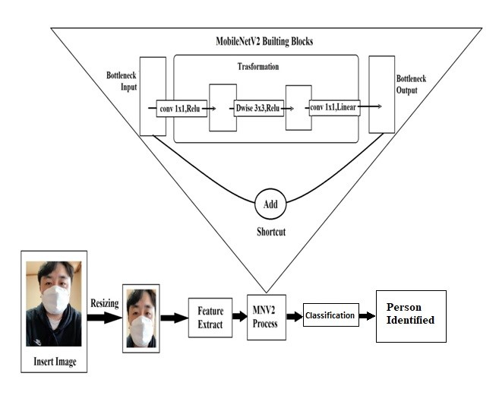

**Fig:** 5.1 Architecture of Face Detection Using OpenCV DNN and SSD

We give the input to the system through bottleneck input method it extracts the feature of the image using Convolutional neural network. It detect the image classification using deep leaning algorithm after classified then it shows the image type that is occulted face or not. It process the image for find the real face of the masked face using deep leaning methods after processed it show the clear face of the occulted face image.

**5.2 SYSTEM STUDY**

**5.2.1 FEASIBILITY STUDY**

The feasibility of the project is analyzed in this phase and business proposal is put forth with a very general plan for the project and some cost estimates. During system analysis the feasibility study of the proposed system is to be carried out. This is to ensure that the proposed system is not a burden to the company. For feasibility analysis, some understanding of the major requirements for the system is essential.

Three key considerations involved in the feasibility analysis are

* Economical Feasibility
* Technical Feasibility
* Social Feasibility

**5.2.2 ECONOMICAL FEASIBILITY**

This study is carried out to check the economic impact that the system will have on the organization. The amount of fund that the company can pour into the research and development of the system is limited. The expenditures must be justified. Thus the developed system as well within the budget and this was achieved because most of the technologies used are freely available. Only the customized products had to be purchased.

### 5.2.3 TECHNICAL FEASIBILITY

This study is carried out to check the technical feasibility, that is, the technical requirements of the system. Any system developed must not have a high demand on the available technical resources. This will lead to high demands on the available technical resources. This will lead to high demands being placed on the client. The developed system must have a modest requirement, as only minimal or null changes are required for implementing this system.

**5.2.4 SOCIAL FEASIBILITY**

The aspect of study is to check the level of acceptance of the system by the user. This includes the process of training the user to use the system efficiently. The user must not feel threatened by the system, instead must accept it as a necessity. The level of acceptance by the users solely depends on the methods that are employed to educate the user about the system and to make him familiar with it. His level of confidence must be raised so that he is also able to make some constructive criticism, which is welcomed, as he is the final user of the system.

**5.3 INPUT DESIGN**

The input design is the link between the information system and the user. It comprises the developing specification and procedures for data preparation and those steps are necessary to put transaction data in to a usable form for processing can be achieved by inspecting the computer to read data from a written or printed document or it can occur by having people keying the data directly into the system. The design of input focuses on controlling the amount of input required, controlling the errors, avoiding delay, avoiding extra steps and keeping the process simple. The input is designed in such a way so that it provides security and ease of use with retaining the privacy. Input Design considered the following things:

* What data should be given as input?
* How the data should be arranged or coded?
* The dialog to guide the operating personnel in providing input.
* Methods for preparing input validations and steps to follow when error occur.

**5.4 OUTPUT DESIGN**

A quality output is one, which meets the requirements of the end user and presents the information clearly. In any system results of processing are communicated to the users and to other system through outputs. In output design it is determined how the information is to be displaced for immediate need and also the hard copy output. It is the most important and direct source information to the user. Efficient and intelligent output design improves the system’s relationship to help user decision-making.

**1**. Designing computer output should proceed in an organized, well thought out manner; the right output must be developed while ensuring that each output element is designed so that people will find the system can use easily and effectively. When analysis design computer output, they should Identify the specific output that is needed to meet the requirements.

**2**. Select methods for presenting information.

**3**. Create document, report, or other formats that contain information produced by the system.

The output form of an information system should accomplish one or more of the following objectives.

* Convey information about past activities, current status or projections of the Future.
* Signal important events, opportunities, problems, or warnings.
* Trigger an action.
* Confirm an action.

**5.5 UML DIAGRAMS**

UML **(**Unified Modeling Language) is a general-purpose visual modeling language that is used to specify, visualize, construct, and document the artifacts of the software system.

UML is a method for describing the system architecture in detail using the blueprint.UML represents a collection of best engineering practices that have proven successful in then modeling of large and complex systems. The UML is a very important part of developing objects oriented software and the software development process. The UML uses mostly graphical notations to express the design of software projects. Using the UML helps project teams communicate, explore potential designs, and validate the architectural design of the software. The UML’s four structural diagrams exist to visualize, specify, construct and document the static aspects of a system. We can view the static parts of a system using one of the following diagrams.

**Goal of UML**

The primary goals in the design of the UML were:

* Provide users with a ready-to-use, expressive visual modeling language so they can develop and exchange meaningful models.
* Provide extensibility and specialization mechanisms to extend the core concepts.
* Be independent of particular programming languages and development processes.
* Provide a formal basis for understanding the modeling language.
* Encourage the growth of the OO tools market.
* Support higher –level development concepts such as collaborations, frameworks, patterns and components.
* Integrate best practices

**Uses of UML**

The UML is intended primarily for software intensive systems. It has been used effectively for such domain as

* Enterprise Information System
* Banking and Financial Services
* Telecommunications
* Transportation
* Defence/Aerospace
* Retails

**Rules of UML**

The UML has semantic rules for,

**NAMES:** It will call things, relationships and diagrams.

**SCOPE:** The content that gives specific meaning to a name.

**VISIBILITY:** How those names can be seen and used by others.

**INTEGRITY:** How things properly and consistently relate to another.

**EXECUTION:** What it means is to run or simulate a dynamic model.

**5.5.1 Use Case Diagram**

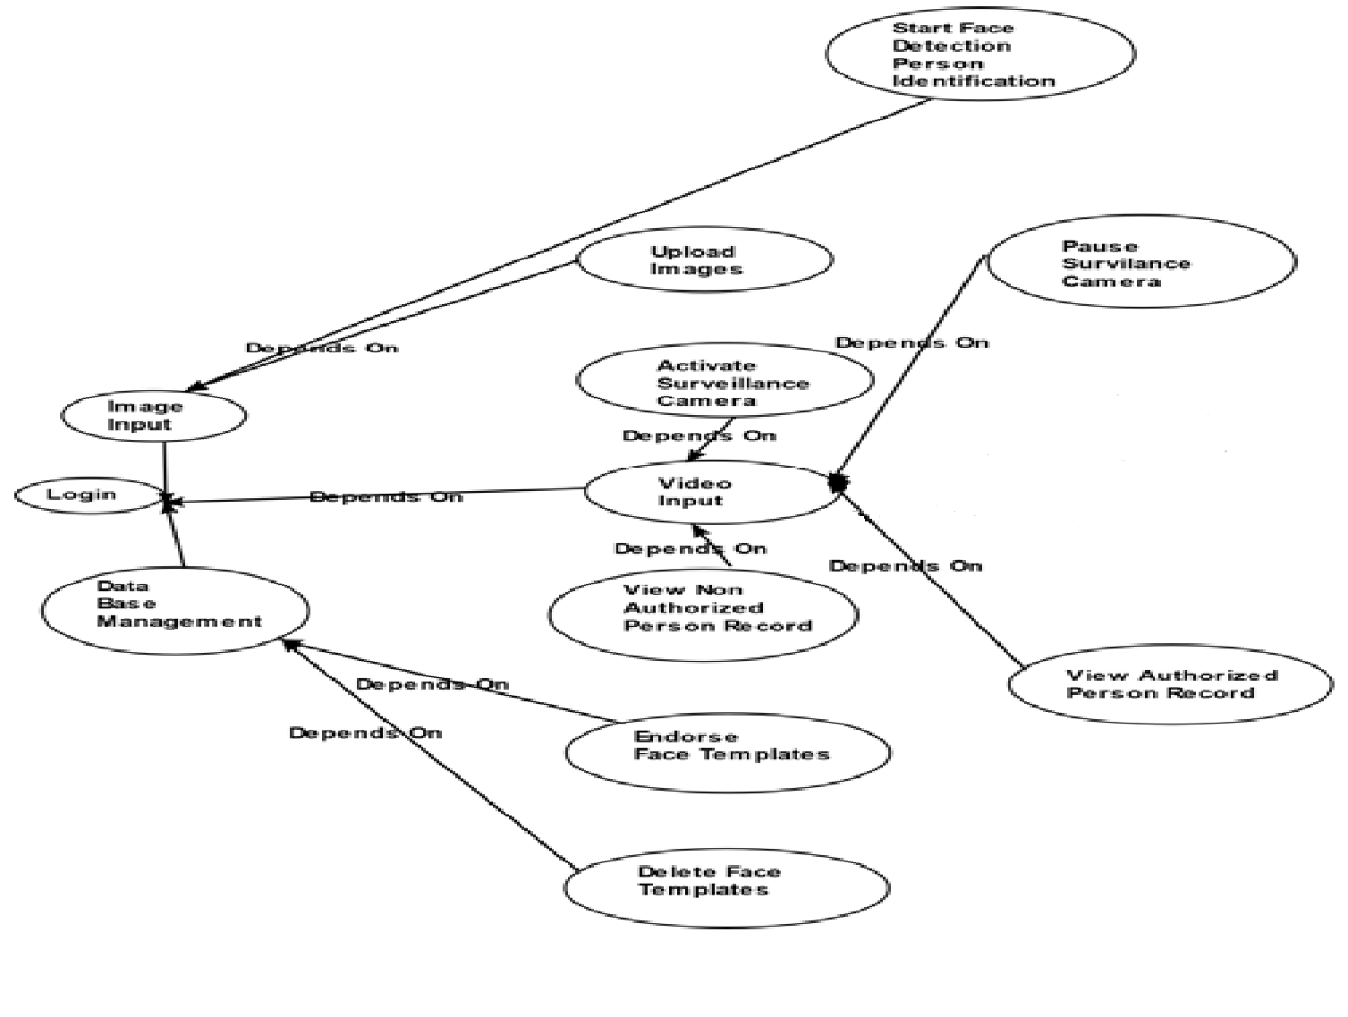

**Fig:** 5.2 Use Case Diagram

**5.5.2 Class Diagram**

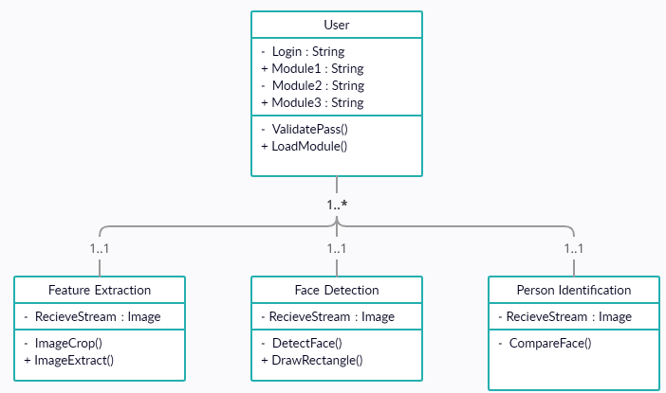

**Fig**: 5.3 Class Diagram

**5.5.3 Sequence Diagram**

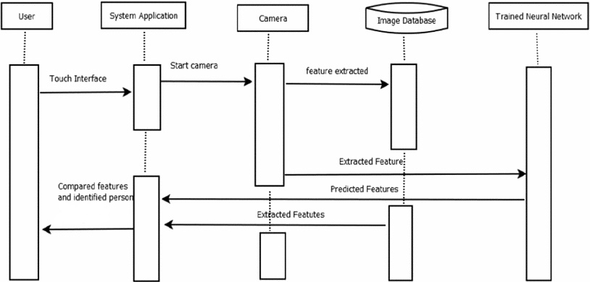

**Fig:** 5.4 Sequence Diagram

**5.5.4 Activity Diagram**

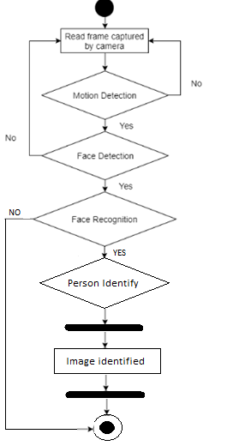

**Fig:** 5.5 Activity Diagram

**CHAPTER 6**

**METHODOLOGY**

**6.1 SUPPORT VECTOR MACHINE**

In machine learning, task of deducing a category from supervised training data is known as Supervised Learning. In supervised learning the training data consist of a set of training examples, where each example is a pair consisting of an input and an anticipated output value. A supervised learning algorithm analyzes the training data and then predicts the correct output categorization for given data-set input. For e.g. Teacher teaches student to identify apple and oranges by giving some features of that. Next time when student sees apple or orange he can easily classify the object based on his learning from his teacher, this is called supervised learning. He can identify the object only if it is apple or orange, but if the given object was grapes the student cannot identify it.

**6.2 MOBILENET-V2**

MobileNet-v2 is a Convolutional neural network that is 53 layers deep. You can load a pre-trained version of the network trained on more than a million images from the Image Net database. The pre-trained network can classify images into 1000 object categories, such as keyboard, mouse, pencil, and many animals. Counting depth wise and point wise convolutions as separate layers, MobileNet has 28 layers.

**6.3 SINGLE-SHOT DETECTOR**

The mobilenet-ssd model is a Single-Shot multi-box Detection (SSD) network intended to perform object detection. This model is implemented using the Caffe* framework. SSD is a single-shot detector. It has no delegated region proposal network and predicts the boundary boxes and the classes directly from feature maps in one single pass. To improve accuracy, SSD introduces: small Convolutional filters to predict object classes and offsets to default boundary boxes.

**6.4 DEEP NEURAL NETWORK**

A deep neural network (DNN) is an artificial neural network (ANN) with multiple layers between the input and output layers. There are different types of neural networks but they always consist of the same components: neurons, synapses, weights, biases, and functions. DNN Platform (formerly "DotNetNuke Community Edition" content management system) is open source software distributed under an MIT License that is intended to allow management of websites without much technical knowledge, and to be extensible through a large number of third-party apps to provide functionality not included in the DNN core modules.

**6.5 CONVOLUTIONAL NEURAL NETWORK**

The name “Convolutional neural network” indicates that the network employs a mathematical operation called convolution. Convolutional networks are a specialized type of neural networks that use convolution in place of general matrix multiplication in at least one of their layers. A Convolutional neural network consists of an input layer, hidden layers and an output layer. In any feed forward neural network, any middle layers are called hidden because their inputs and outputs are masked by the activation function and final convolution. In a Convolutional neural network, the hidden layers include layers that perform convolutions.

**CHAPTER 7**

**IMPLEMENTATION**

**7.1 MODULES**

Here, using three modules. They are,

1. Feature extraction
2. Face detection
3. Person identification

**7.2 MODULES DESCRIPTION**

**7.2.1 Feature extraction**

In this first module, it gets the input image like masked face or unmasked face from the user. It crop the image and resize the image for the feature extraction this feature extraction is helpful for the detection of face while mask wore or not this process is done by the deep learning method Convolutional neural network algorithm. This algorithm is done the feature extraction process. After extract the image it goes to the second module.

**7.2.2 Face Detection**

In this second module, it detects the input image by the help of bottle neck input method. Here the mobilenetV2 is used to detect or identify the image that the face is covered with veil or not. It trained by the process of detecting images, after classified the image it show the image type like wore (or) not. Then this module output goes to the third module.

**7.2.3 Person Identification**

In third module, the detected image is compared to the image collected database to find the real face of the masked face. After compared the faces it recognized the real face of the masked face from the image database. Finally it shows the output image of the owner of the masked face. Finally its terminate their process.

**CHAPTER 8**

**SYSTEM TESTING**

**8.1 VERIFICATION AND VALIDATION**

Verification is the process of checking that software achieves its goal without any bugs. It is the process to ensure whether the product that is developed is right or not. It verifies whether the developed product fulfils the requirements that we have. Verification is Static Testing.

**Verification:** Are we building the product right?

Validation is the process of checking whether the software product is up to the mark or in other words product has high level requirements. It is the process of checking the validation of product i.e. it checks what we are developing is the right product. it is validation of actual and expected product.

Validation is the Dynamic Testing.

**Validation:** Are we building the right product?

### 8.2 SYSTEM TESTING

The purpose of testing is to discover errors. Testing is the process of trying to discover every conceivable fault or weakness in a work product. It provides a way to check the functionality of components, sub assemblies, assemblies and/or a finished product It is the process of exercising software with the intent of ensuring that the Software system meets its requirements and user expectations and does not fail in an unacceptable manner. There are various types of test. Each test type addresses a specific testing requirement.

**8.3 TYPES OF TESTS**

**8.3.1 Unit testing**

Unit testing involves the design of test cases that validate that the internal program logic is functioning properly, and that program inputs produce valid outputs. All decision branches and internal code flow should be validated. It is the testing of individual software units of the application .it is done after the completion of an individual unit before integration. This is a structural testing, that relies on knowledge of its construction and is invasive. Unit tests perform basic tests at component level and test a specific business process, application, and/or system configuration. Unit tests ensure that each unique path of a business process performs accurately to the documented specifications and contains clearly defined inputs and expected results.

**8.3.2 Functional test**

Functional tests provide systematic demonstrations that functions tested are available as specified by the business and technical requirements, system documentation, and user manuals.

Functional testing is cantered on the following items:

* Valid Input: identified classes of valid input must be accepted.
* Invalid Input: identified classes of invalid input must be rejected.
* Functions: identified functions must be exercised.
* Output: identified classes of application outputs must be exercised
* Systems/Procedures: interfacing systems or procedures must be invoked

Organization and preparation of functional tests is focused on requirements, key functions, or special test cases. In addition, systematic coverage pertaining to identify Business process flows; data fields, predefined processes, and successive processes must be considered for testing. Before functional testing is complete, additional tests are identified and the effective value of current tests is determined.

**8.3.3 System Test**

System testing ensures that the entire integrated software system meets requirements. It tests a configuration to ensure known and predictable results. An example of system testing is the configuration oriented system integration test. System testing is based on process descriptions and flows, emphasizing pre-driven process links and integration points.

**8.3.4 White Box Testing**

White Box Testing is a testing in which in which the software tester has knowledge of the inner workings, structure and language of the software, or at least its purpose. It is purpose. It is used to test areas that cannot be reached from a black box level.

**8.3.5 Black Box Testing**

Black Box Testing is testing the software without any knowledge of the inner workings, structure or language of the module being tested. Black box tests, as most other kinds of tests, must be written from a definitive source document, such as specification or requirements document, such as specification or requirements document. It is a testing in which the software under test is treated, as a black box .you cannot “see” into it. The test provides inputs and responds to outputs without considering how the software works.

**8.3.6 Integration Testing**

Integration tests are designed to test integrated software components to determine if they actually run as one program. Testing is event driven and is more concerned with the basic outcome of screens or fields. Integration tests demonstrate that although the components were individually satisfaction, as shown by successfully unit testing, the combination of components is correct and consistent. Integration testing is specifically aimed at exposing the problems that arise from the combination of components.

Software integration testing is the incremental integration testing of two or more integrated software components on a single platform to produce failures caused by interface defects.

The task of the integration test is to check that components or software applications, e.g. components in a software system or – one step up – software applications at the company level – interact without error.

Software integration testing is the incremental integration testing of two or more integrated software components on a single platform to produce failures caused by interface defects.

The task of the integration test is to check that components or software applications, e.g. components in a software system or – one step up – software applications at the company level – interact without error.

**Test Results:** All the test cases mentioned above passed successfully. No defects encountered.

8.3.7 Acceptance Testing

User Acceptance Testing is a critical phase of any project and requires significant participation by the end user. It also ensures that the system meets the functional requirements.

**Test Results:** All the test cases mentioned above passed successfully. No defects encountered.

8.4 TEST STRATEGY AND APPROACH

Field testing will be performed manually and functional tests will be written in detail.

**8.4.1 Test objectives**

* All field entries must work properly.
* Pages must be activated from the identified link.
* The entry screen, messages and responses must not be delayed.

**8.4.2 Features to be tested**

* Verify that the entries are of the correct format
* No duplicate entries should be allowed
* All links should take the user to the correct page.

**CHAPTER 9**

**CONCLUSION**

This project original copy introduced an examination on constant facemask acknowledgment with an alert framework through profound learning procedures via Convolution Neural Organizations. This interaction gives an exact and quickly results for facemask discovery. The test outcomes show a recognized precision rate in recognizing people wearing a facemask or not wearing a facemask and also person identification. The prepared model had the option to perform its endeavour utilizing the VGG-16 CNN model accomplishing a 96% outcome for execution exactness. Also, the examination presents a valuable instrument in battling the spread of the COVID-19 infection by distinguishing an individual who wears a facemask or not and sets an alert if the individual isn't wearing a facemask. Future works incorporate the reconciliation of physical separating, wherein the camera recognizes the individual wearing a facemask or not and simultaneously quantifies the distance between every individual and makes a caution if the physical separating doesn't notice appropriately.

**CHAPTER 10**

**FUTURE ENHANCEMENT**

Further this system development, we could improve the range of the public place. Because this project will helpful for small places like school, industrial organizations, exam centre and etc... And here after the future enhancement is add the people details that are the details of the person.

These features are added in this project then this project goes to be a very helpful for this society. Because this project goes to help for the college/school, companies and other places and also it is very helpful for the police department.

**APPENDIX- I**

**SCREENSHOTS**

**STEP 1:** Opening Matlab.**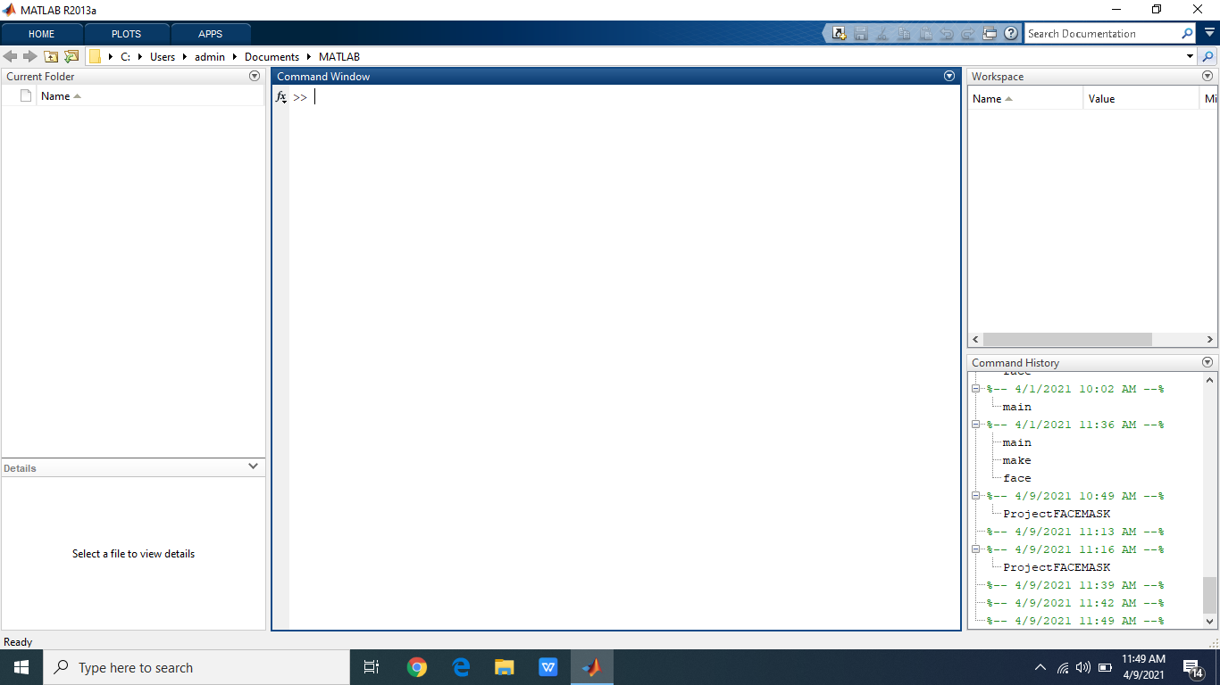Step 2:** Choose the Directory.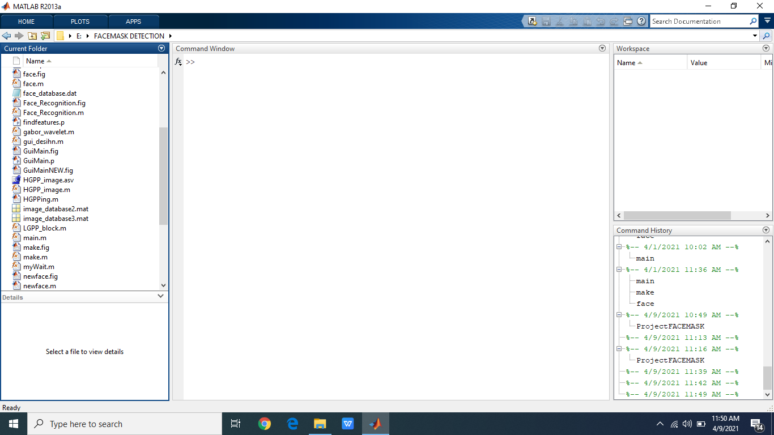

**Step 3:** Run GuiMain.p File.

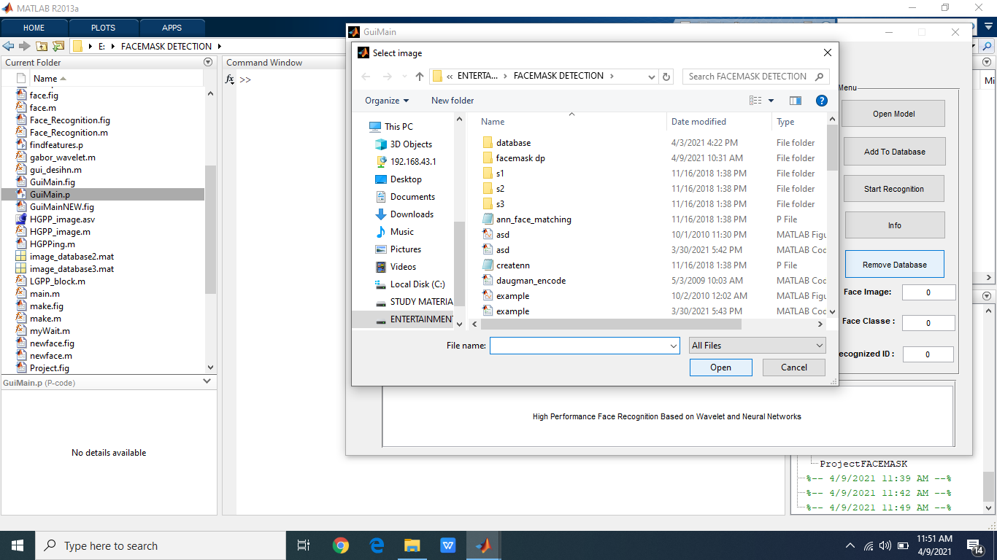

**Step 4:** Choose The Photo With Mask.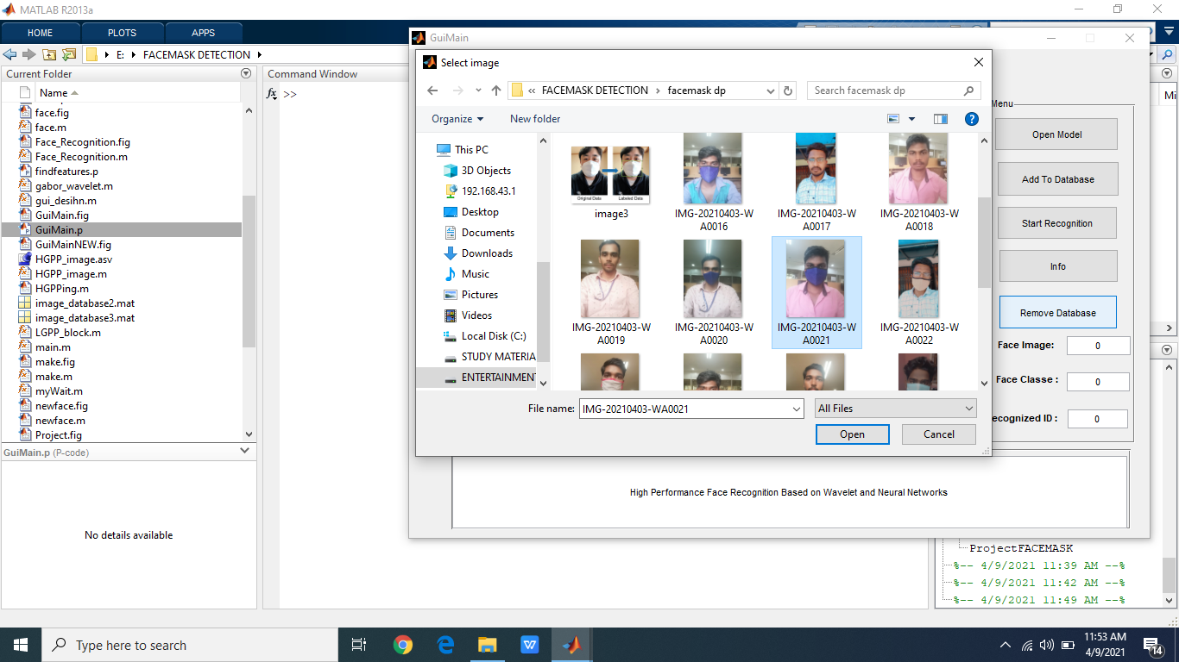

**Step 5:** Choose Add To Database.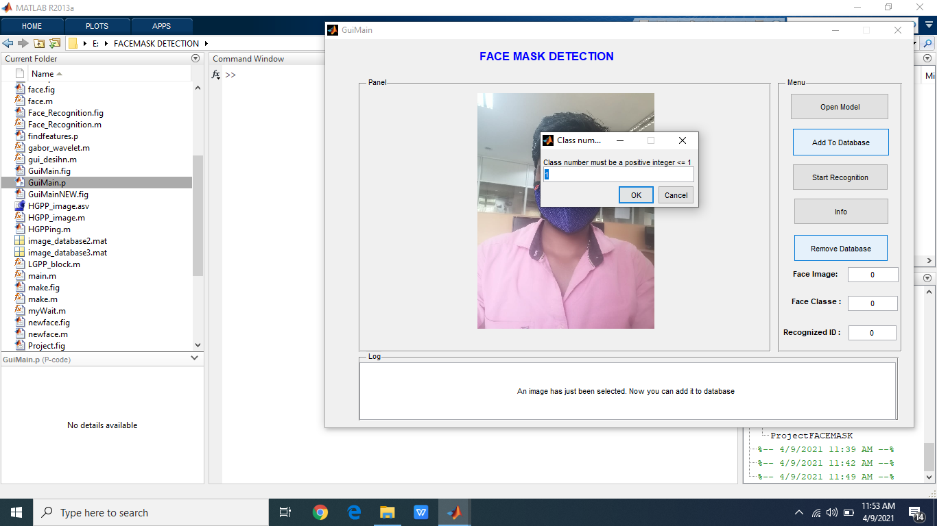

**Step 6:** Click To Start Recognition**.**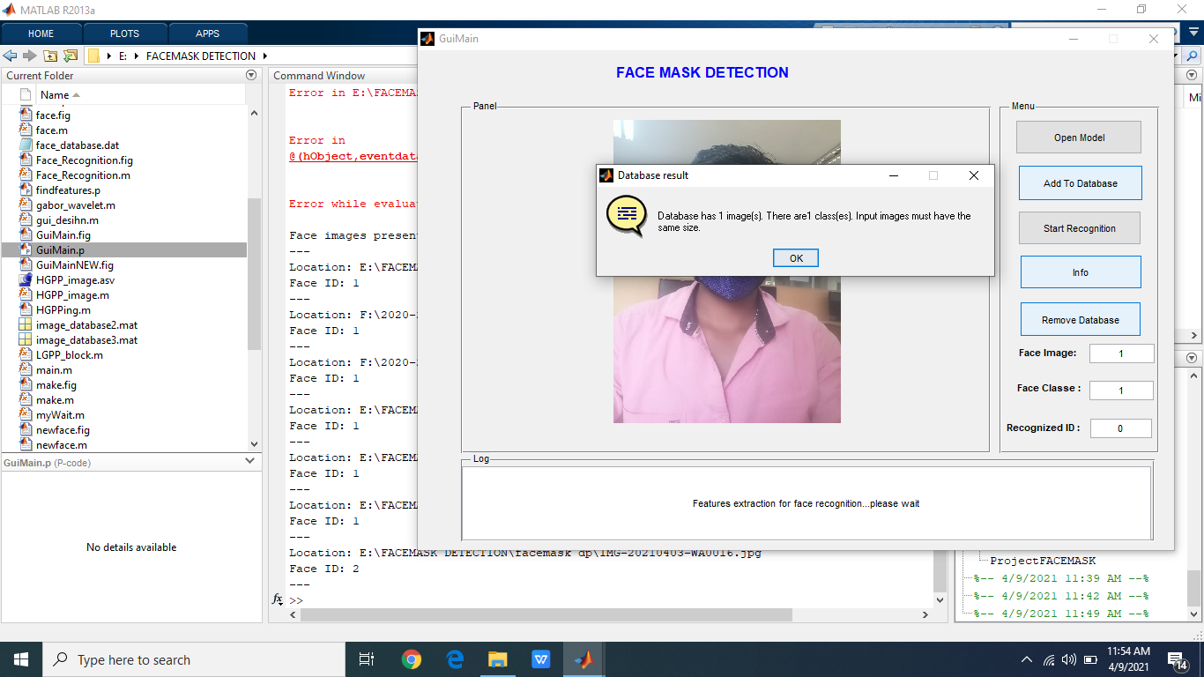

**Step 7:** Person Identification Screen.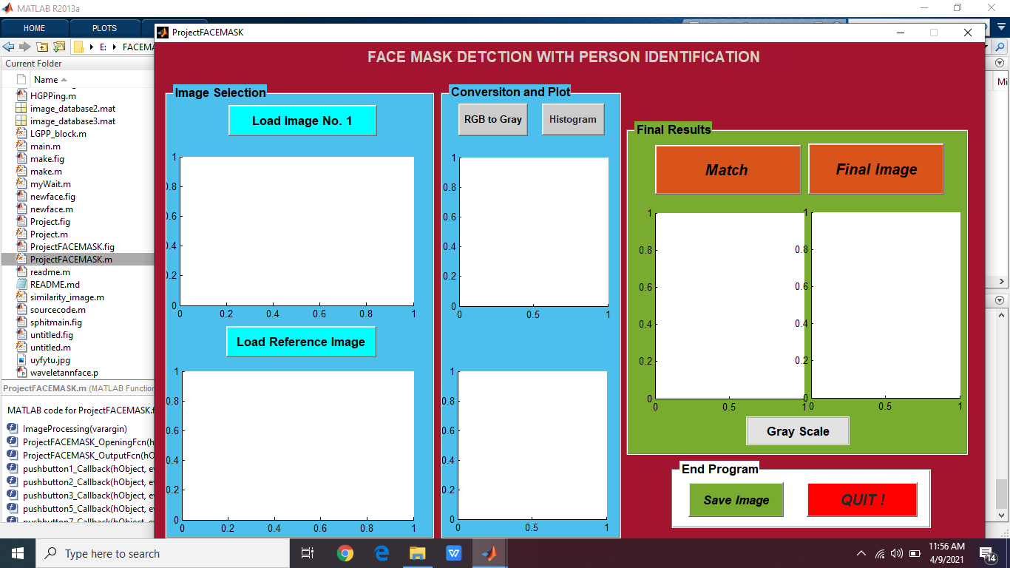

**Step 8:** Upload The Unmask Face Image.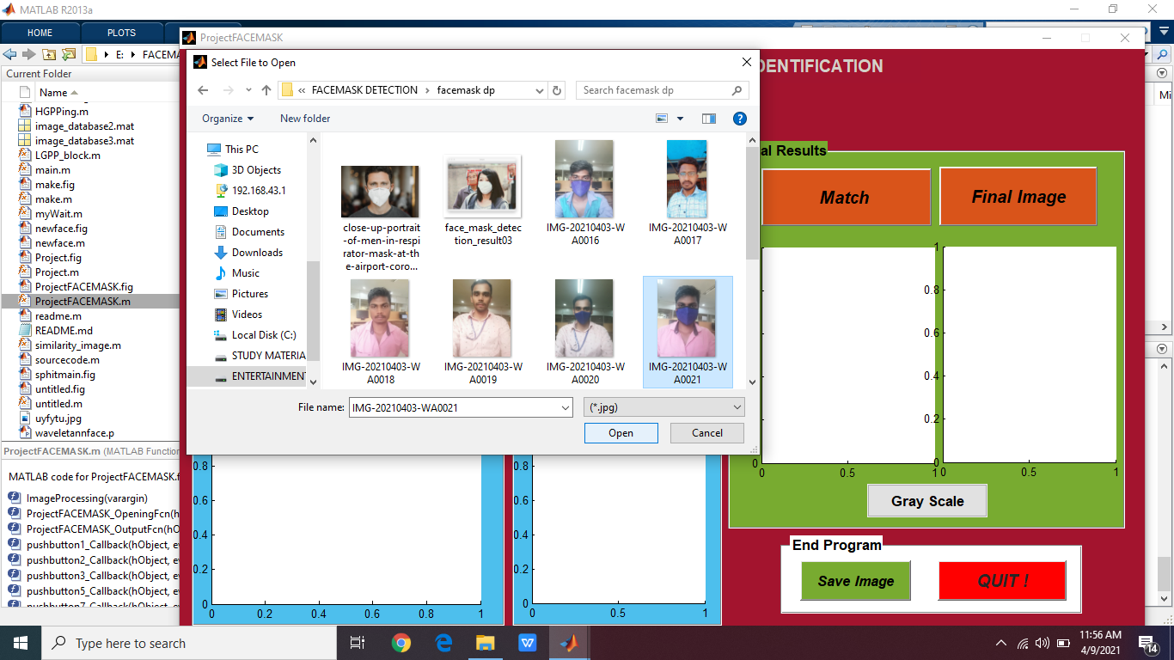

**Step 9:** we get the GrayScale Image.

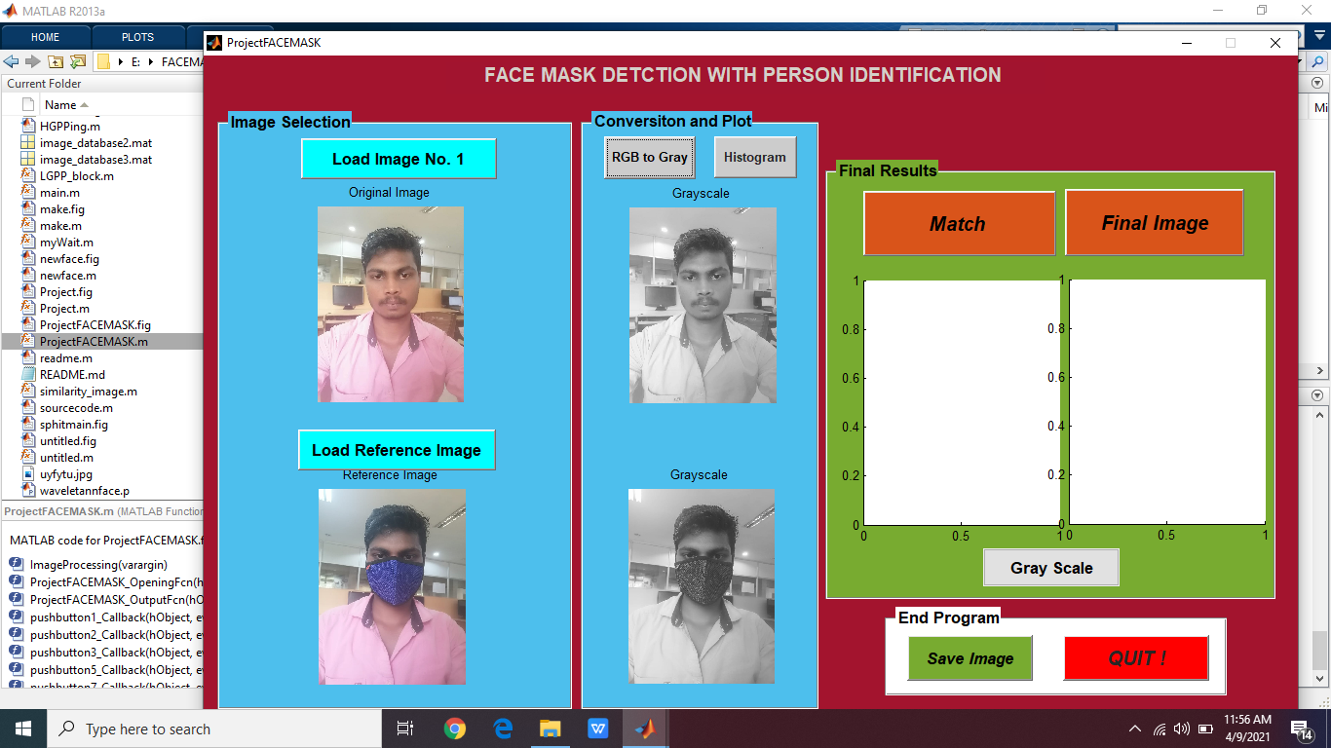

**Step 10:** Here get the final image output of the given image.

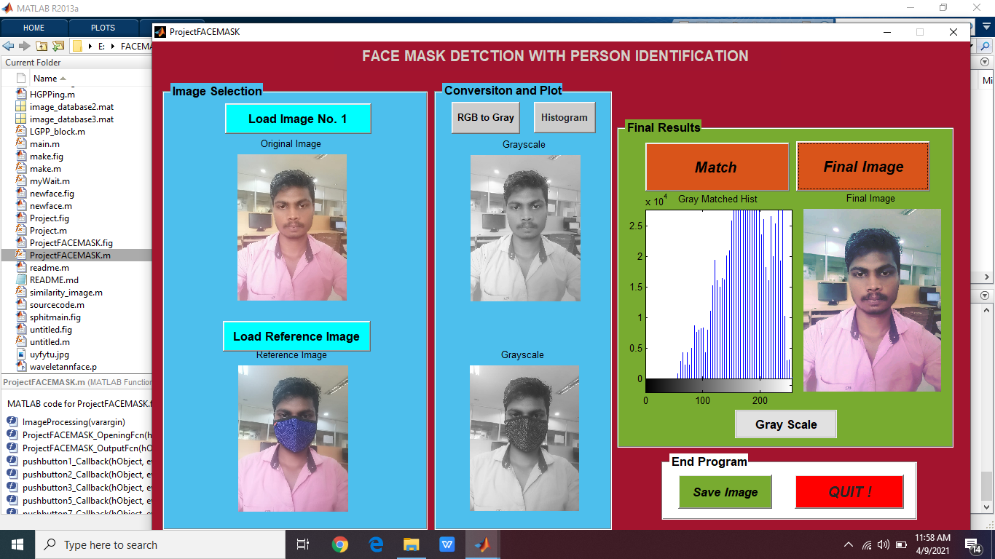

**APPENDIX - II**

**CODING**

function [bbox,score, label] = yolov2_detect(in, th)

persistent yolov2Obj;

if isempty(yolov2Obj)

yolov2Obj = coder.loadDeepLearningNetwork('COVID19_Mask_yolo.mat');

end

[bbox, score, label] = yolov2Obj.detect(in,'Threshold',th);

%Copyright 2020 The MathWorks, Inc.

function [bbox,score, label] = ssd_detect(in, th)

persistent ssdObj;

if isempty(ssdObj)

ssdObj = coder.loadDeepLearningNetwork('COVID19_Mask_SSD.mat');

end

[bbox, score, label] = ssdObj.detect(in,'Threshold',th);

%Copyright 2020 The MathWorks, Inc.

function selectedBbox = predictFace(img_rz, matfile)

%#codegen

% This function detects the traffic signs in the image using Detection Network

% (modified version of Yolo) and recognizes(classifies) using Recognition Network

%

% Inputs :

%

% im : Input test image

%

% Outputs :

%

% selectedBbox : Detected bounding boxes

% idx : Corresponding classes

% Converting into BGR format

img_rz = img_rz(:,:,3:-1:1);

img_rz = im2single(img_rz);

%% TSD

persistent detectionnet;

if isempty(detectionnet)

detectionnet = coder.loadDeepLearningNetwork(matfile,'Detection');

end

predictions = detectionnet.predict(img_rz);%, 'executionenvironment', 'cpu');

%% Convert predictions to bounding box attributes

classes = 1;

num = 2;

side = 11;

thresh = 0.2;

[h,w,~] = size(img_rz);

boxes = single(zeros(0,4));

probs = single(zeros(0,1));

for i = 0:(side*side)-1

for n = 0:num-1

p_index = side*side*classes + i*num + n + 1;

scale = predictions(p_index);

prob = zeros(1,classes+1);

for j = 0:classes

class_index = i*classes + 1;

tempProb = scale*predictions(class_index+j);

if tempProb > thresh

row = floor(i / side);

col = mod(i,side);

box_index = side*side*(classes + num) + (i*num + n)*4 + 1;

bxX = (predictions(box_index + 0) + col) / side;

bxY = (predictions(box_index + 1) + row) / side;

bxW = (predictions(box_index + 2)^2);

bxH = (predictions(box_index + 3)^2);

prob(j+1) = tempProb;

probs = [probs;tempProb];

boxX = (bxX-bxW/2)*w+1;

boxY = (bxY-bxH/2)*h+1;

boxW = bxW*w;

boxH = bxH*h;

boxes = [boxes; boxX,boxY,boxW,boxH];

end

end

end

end

%% Run Non-Maximal Suppression on the detected bounding boxess

coder.varsize('selectedBbox',[98, 4],[1 0]);

[selectedBbox,~] = selectStrongestBbox(round(boxes),probs);

classdef FaceMaskDetection < vision.labeler.AutomationAlgorithm

properties(Constant)

Name = 'Face Mask Detection';

Description = 'This is a automatic Mask labeling algorithm.';

UserDirections = {...

['Automation algorithms are a way to automate manual labeling ' ...

'tasks. This AutomationAlgorithm is a template for creating ' ...

'user-defined automation algorithms. Below are typical steps' ...

'involved in running an automation algorithm.'], ...

['Run: Press RUN to run the automation algorithm. '], ...

['Review and Modify: Review automated labels over the interval ', ...

'using playback controls. Modify/delete/add ROIs that were not ' ...

'satisfactorily automated at this stage. If the results are ' ...

'satisfactory, click Accept to accept the automated labels.'], ...

['Change Settings and Rerun: If automated results are not ' ...

'satisfactory, you can try to re-run the algorithm with ' ...

'different settings. In order to do so, click Undo Run to undo ' ...

'current automation run, click Settings and make changes to ' ...

'Settings, and press Run again.'], ...

['Accept/Cancel: If results of automation are satisfactory, ' ...

'click Accept to accept all automated labels and return to ' ...

'manual labeling. If results of automation are not ' ...

'satisfactory, click Cancel to return to manual labeling ' ...

'without saving automated labels.']};

end

properties

AllCategories = {'background'};

FireName

count

end

methods

function isValid = checkLabelDefinition(algObj, labelDef)

disp(['Executing checkLabelDefinition on label definition "' labelDef.Name '"'])

if (strcmpi(labelDef.Name, 'Mask') && labelDef.Type == labelType.Rectangle)

isValid = true;

algObj.FireName = labelDef.Name;

algObj.AllCategories{end+1} = labelDef.Name;

end

end

function isReady = checkSetup(algObj)

isReady = ~isempty(algObj);

end

function settingsDialog(algObj)

disp('Executing settingsDialog')

end

end

methods

function initialize(algObj, I)

disp('Executing initialize on the first image frame')

end

function autoLabels = run(algObj, I)

disp('Executing run on image frame')

[labelCord, label] = MaskLabel(I, algObj);

autoLabels.Name = char(label);

autoLabels.Type = labelType('Rectangle');

autoLabels.Position = labelCord;

algObj.count = algObj.count+1;

end

function terminate(algObj)

disp('Executing terminate')

end

end

end

function varargout = cancer(varargin)

% CANCER M-file for cancer.fig

% CANCER, by itself, creates a new CANCER or raises the existing

% singleton*.

%

% H = CANCER returns the handle to a new CANCER or the handle to

% the existing singleton*.

%

% CANCER('CALLBACK',hObject,eventData,handles,...) calls the local

% function named CALLBACK in CANCER.M with the given input arguments.

%

% CANCER('Property','Value',...) creates a new CANCER or raises the

% existing singleton*. Starting from the left, property value pairs are

% applied to the GUI before cancer_OpeningFcn gets called. An

% unrecognized property name or invalid value makes property application

% stop. All inputs are passed to cancer_OpeningFcn via varargin.

%

% *See GUI Options on GUIDE's Tools menu. Choose "GUI allows only one

% instance to run (singleton)".

%

% See also: GUIDE, GUIDATA, GUIHANDLES

% Edit the above text to modify the response to help cancer

% Last Modified by GUIDE v2.5 27-Feb-2014 18:25:32

% Begin initialization code - DO NOT EDIT

gui_Singleton = 1;

gui_State = struct('gui_Name', mfilename, ...

'gui_Singleton', gui_Singleton, ...

'gui_OpeningFcn', @cancer_OpeningFcn, ...

'gui_OutputFcn', @cancer_OutputFcn, ...

'gui_LayoutFcn', [] , ...

'gui_Callback', []);

if nargin && ischar(varargin{1})

gui_State.gui_Callback = str2func(varargin{1});

end

if nargout

[varargout{1:nargout}] = gui_mainfcn(gui_State, varargin{:});

else

gui_mainfcn(gui_State, varargin{:});

end

% End initialization code - DO NOT EDIT

% --- Executes just before cancer is made visible.

function cancer_OpeningFcn(hObject, eventdata, handles, varargin)

% This function has no output args, see OutputFcn.

% hObject handle to figure

% eventdata reserved - to be defined in a future version of MATLAB

% handles structure with handles and user data (see GUIDATA)

% varargin command line arguments to cancer (see VARARGIN)

% Choose default command line output for cancer

handles.output = hObject;

% Update handles structure

guidata(hObject, handles);

% UIWAIT makes cancer wait for user response (see UIRESUME)

% uiwait(handles.figure1);

% --- Outputs from this function are returned to the command line.

function varargout = cancer_OutputFcn(hObject, eventdata, handles)

% varargout cell array for returning output args (see VARARGOUT);

% hObject handle to figure

% eventdata reserved - to be defined in a future version of MATLAB

% handles structure with handles and user data (see GUIDATA)

% Get default command line output from handles structure

varargout{1} = handles.output;

% --- Executes on button press in pushbutton1.

function pushbutton1_Callback(hObject, eventdata, handles)

% hObject handle to pushbutton1 (see GCBO)

% eventdata reserved - to be defined in a future version of MATLAB

% handles structure with handles and user data (see GUIDATA)

global I

clc

[filename, pathname] = uigetfile('*.jpg', 'Pick an Image');

if isequal(filename,0) | isequal(pathname,0)

warndlg('File is not selected');

else

I=imread(filename);

axes(handles.axes1)

imshow(I);

title 'Input Image'

end

title 'Input Lung Image'

% --- Executes on button press in pushbutton2.

function pushbutton2_Callback(hObject, eventdata, handles)

% hObject handle to pushbutton2 (see GCBO)

% eventdata reserved - to be defined in a future version of MATLAB

% handles structure with handles and user data (see GUIDATA)

global I

t=rgb2gray(I);

he=histeq(t);

axes(handles.axes2);

imshow(he);

title 'Histogram Equalization'

% --- Executes on button press in pushbutton3.

function pushbutton3_Callback(hObject, eventdata, handles)

% hObject handle to pushbutton3 (see GCBO)

% eventdata reserved - to be defined in a future version of MATLAB

% handles structure with handles and user data (see GUIDATA)

global I

%% Histogram Equalization

t=rgb2gray(I);

he=histeq(t);

%% Segmentation by thresholding

threshold = graythresh(he);

bw = im2bw(he,threshold);

axes(handles.axes3);

imshow(bw)

title 'Segmentation by Thresholding'

% --- Executes on button press in pushbutton4.

function pushbutton4_Callback(hObject, eventdata, handles)

% hObject handle to pushbutton4 (see GCBO)

% eventdata reserved - to be defined in a future version of MATLAB

% handles structure with handles and user data (see GUIDATA)

global I

%% Histogram Equalization

t=rgb2gray(I);

he=histeq(t);

%% Segmentation by thresholding

threshold = graythresh(he);

bw = im2bw(he,threshold);

%% Filter

hy = fspecial('sobel');

hx = hy';

Iy = imfilter(double(bw), hy, 'replicate');

axes(handles.axes4);

imshow(Iy,[]),

title('Filtered Image')

% --- Executes on button press in pushbutton5.

function pushbutton5_Callback(hObject, eventdata, handles)

% hObject handle to pushbutton5 (see GCBO)

% eventdata reserved - to be defined in a future version of MATLAB

% handles structure with handles and user data (see GUIDATA)

global I

%% Histogram Equalization

t=rgb2gray(I);

he=histeq(t);

%% Segmentation by thresholding

threshold = graythresh(he);

bw = im2bw(he,threshold);

%% Filter

hy = fspecial('sobel');

hx = hy';

Iy = imfilter(double(bw), hy, 'replicate');

se = strel('line',11,90);

bw2 = imdilate(Iy,se);

axes(handles.axes5);

imshow(bw2),

title('Dilated')

% --- Executes on button press in pushbutton6.

function pushbutton6_Callback(hObject, eventdata, handles)

% hObject handle to pushbutton6 (see GCBO)

% eventdata reserved - to be defined in a future version of MATLAB

% handles structure with handles and user data (see GUIDATA)

global I

%% Histogram Equalization

t=rgb2gray(I);

he=histeq(t);

%% Segmentation by thresholding

threshold = graythresh(he);

bw = im2bw(he,threshold);

%% Filter

hy = fspecial('sobel');

hx = hy';

Iy = imfilter(double(bw), hy, 'replicate');

se = strel('line',11,90);

bw2 = imdilate(Iy,se);

BW5 = imfill(bw2,'holes');

axes(handles.axes6);

imshow(BW5)

title 'Image Filling'

% --- Executes on button press in pushbutton7.

function pushbutton7_Callback(hObject, eventdata, handles)

% hObject handle to pushbutton7 (see GCBO)

% eventdata reserved - to be defined in a future version of MATLAB

% handles structure with handles and user data (see GUIDATA)

global I

% figure,imshow(I);

% title 'Input Lung Image'

%% Histogram Equalization

t=rgb2gray(I);

he=histeq(t);

% figure,imshow(he);

% title 'Histogram Equalization'

%% Segmentation by thresholding

**REFERENCES**

[1] Bai, Y., Yao, L., Wei, T., Tian, F., Jin, D. Y., Chen, L., & Wang, M. (2020). Presumed Asymptomatic Carrier Transmission of COVID-19. JAMA, 323(14), 1406–1407. Advance online publication https://doi.org/10.1001/jama.2020.2565

[2] Chavez, S., Long, B., Koyfman, A. & Liang, S. Y. Corona virus Disease(COVID-19): A primer for emergency physicians. Am J Emerg Med, https://doi:10.1016/j.ajem.2020.03.036 (2020).

[3] Cowling, B. J. et al. Facemasks and hand hygiene to prevent influenza transmission in households: a cluster randomized trial. Ann Intern Med151, 437-446, https://doi:10.7326/0003-4819-151-7-20091006000142 (2009).

[4] Centres for Disease Control and Prevention. Interim Infection Prevention and Control Recommendations for Patients with Suspected or Confirmed Corona virus Disease 2019 (COVID-19) in Healthcare Settings. 2020 [cited 5 June 2020]https://www.cdc.gov/coronavirus/2019-ncov/hcp/infection-controlrecommendations.html

[5] Feng, S., Shen, C., Xia, N., Song, W., Fan, M., & Cowling, B. J. (2020)Rational use of face masks in the COVID-19 pandemic. The Lancet Respiratory,medicine,8(5),434–436.https://doi.org/10.1016/S22132600(20)30134X

[6] Jefferson, T. et al. Physical interventions to interrupt or reduce thspread of respiratory viruses. Cochrane Database Syst Rev, CD006207 https://doi:10.1002/14651858.CD006207.pub4 (2011).

[7] Korea Centers for Disease Control and Prevention. Infection Prevention and Control Recommendations for Patients with Suspected or Confirmed Coronavirus Disease 2019 (COVID-19) in Healthcare Settings [in Korean]. 2020 [cited June 2020]http://ncov.mohw.go.kr/duBoardList.do?brdId=2&brdGubun=28

[8] LeCun, Y., Kavukcuoglu, K., Farabet, C. & Ieee. in 2010 Ieee International Symposium on Circuits and Systems IEEE International Symposium on Circuits and Systems 253-256 (2010).

[9] Sim, S. W., Moey, K. S. & Tan, N. C. The use of facemasks to prevenrespiratory infection: a literature review in the context of the Health Belief Model. Singapore Med J 55, 160-167https://doi:10.11622/smedj.2014037 (2014).

[10] Tracht, S. M., Del Valle, S. Y. & Hyman, J. M. Mathematical modelingof the effectiveness of facemasks in reducing the spread of novel influenza A (H1N1). PLoS One 5, e9018https://doi:10.1371/journal.pone.0009018 (2010).

[11] World Health Organization. Corona virus disease 2019 (COVID-19Situation Report– 142, 2020, [cited 10 June 2020]https://www.who.int/docs/default-source/coronaviruse/situationreports/20200610-covid-19-sitrep-142.pdf?sfvrsn=180898cd_6

[12] Yu, P., Zhu, J., Zhang, Z., & Han, Y. (2020). A Familial Cluster infection Associated With the 2019 Novel Corona virus Indicating Possible Person-to-Person Transmission During the Incubation Period The Journal of infectious diseases, 221(11), 1757–1761https://doi.org/10.1093/infdis/jiaa077

[13] Zhang, K. P., Zhang, Z. P., Li, Z. F. & Qiao, Y. Joint Face Detection and Alignment Using Multi-task Cascaded Convolutional NetworksIeee Signal Proc Let 23, 1499-1503, https://doi:10.1109/Lsp.2016.26s03342 (2016).